**California State University, Fullerton &**

**INNVOTEC**

**Presents**

|  |  |
| --- | --- |
| [Document title]  [Document subtitle] | Abstract  [Draw your reader in with an engaging abstract. It is typically a short summary of the document. When you’re ready to add your content, just click here and start typing.]  priyanka.6  [Course title] |

**CALIFORNIA STATE UNIVERSITY, FULLERTON**



**SOFTWARE MAINTENANCE**

**Spring 2019**

**Professor: Son Nguyen**

**Submitted by: Pavan Kumar Koikur Sudhakar, Parijat Das**

**Priyanka Sharma, Priyanka Sri Ramasetty,**

**Rani Bishnoi, Manjushree Shivarudraiah,**

**Jai Santosh Mandava, Yashaswani Bommanayakanahalli Mahalinga P**

**ACKNOWLEDGEMENT**

This product guide package is solely made for the course of Software Maintenance. It was not possible to do this without the guidance of our respected Professor, Son Nguyen. His constant efforts and guidance helped the team at Innvotec to be able to think of and build this product called “IVector”. We deeply thank all the team participants who made this possible.

**TABLE OF CONTENTS**

1. **Introduction**
   1. Team Name………………………………………………………………………………..4
   2. Team members and roles………………………………………………………..….4
2. **The Software Product**
   1. Product Name…………………………………………………………………………….5
   2. Product/Brand Logo……………………………………………………………………5
   3. Product Vision…………………………………………………………………………….5
3. **Product and Market**
   1. Sales Pitch…………………………………………………………………………………..6
   2. Key Selling Points………………………………………………………………………..6
4. **Concepts of Operation**
   1. System Block Diagram………………………………………………………………...7
5. **Features**
   1. Capabilities………………………………………………………………………………….9
6. **Implementation**
   1. Physical view……………………………………………………………………………….20
   2. Wireframe Mock-ups…………………………………………………………………..28
7. **Logistics**
   1. Warranty Policy……………………………………………………………………………29
   2. Pricing………………………………………………………………………………………….29
8. **Future**……………………………………………………………………………………………………30

**Contact Information**……………………………………………………………………………..32

**References**…………………………………………………………………………………………….33

**1. INTRODUCTION**

Innvotec works towards innovation and is driven by hardworking and dedicated employees. It is not just a brand but an innovation center. In the year 2019, Innvotec was given a task (under software maintenance) to develop an innovative product. The clients made the company aware of the competitiveness in the market and the need to be unique. Therefore, as always Innvotec came up with our brand-new product the new and smart I-Vector, which is nothing but a smart vacuum cleaner. It possesses extra-ordinary capabilities and with the utter support from our product owner, scrum master and the team we proudly present this product guide package, which includes this document, scrum artifacts and much more.

**Team Name: INNVOTEC**

**Members and their roles:**

**Product Owner: PAVAN KUMAR KOIKUR SUDHAKAR**

**Scrum Master : PRIYANKA SHARMA**

**Team Members:**

**MANJUSHREE SHIVARUDRAIAH**

**PARIJAT DAS**

**PRIYANKA SRI RAMASETTY**

**RANI BISHNOI**

**JAI SANTOSH MANDAVA**

**YASHASWINI BOMMANAYAKANAHALLI MAHALINGA P**

**2. THE SOFTWARE PRODUCT**

**Product Name: IVector ->** this unique name for our product comes up from the basic idea that our team works in the innovative direction while giving results with huge magnitude. Therefore, our recent product the smart vacuum cleaner is based on this idea of development and our team will make sure that this product satisfies the customer and market needs in order to stand out as a successful product.

**Brand Logo:**



**Product Vision**

**“ IVector is basically a machine mediator which is designed to connect and communicate with other devices in addition to smart cleaning of the rooms. “**

**3. PRODUCT AND MARKET**

**Sales Pitch:**

**Key Selling Points:**

**“MAKE PEOPLE’S LIFE BETTER WITH OUR PRODUCT!”**

* Self-Charging capabilities
* Low maintenance compared to others
* Compact design
* Fault detection
* Automatic adjustment to multiple surfaces
* No manual operation
* Easy to operate

**4. CONCEPTS OF OPERATION**

**System Block Diagram:**



**Figure 1: Block diagram of the smart vacuum cleaner**

The smart vacuum cleaner is made up of the following parts.

LED: Intelligent LEDs of 16*2 displays are used in the manufacturing of a smart vacuum cleaner. It is used to display the alphanumeric characters based on ASCII code. All the information sent to the user and the information received by the vacuum cleaner is displayed on the LED connected to it.

Power supply: The power supply is designed to convert the incoming high AC voltage to a suitable voltage supply for electronic circuits. The vacuum cleaner can work on the batteries as well. The battery is a electronic cell which stores energy and converts it to electrical energy. It consists of 2 or more cells arranged in parallel or series. Normally a rechargeable battery also can be used for this. The battery can be charged using solar energy. It can be attached and detached from the vacuum cleaner easily.

Ultrasonic sensors: This sensor is a high-performance sensor. It ranges from 2 to 4 cm. It is directly connected to the microcontroller. The data detected by the sensor is displayed on the LED. The sensors work in such a way that they collect data all around. It scans the obstacles and sets directions for the cleaner to move. According to the sensor directions the cleaning process will be done.

Bluetooth: This is a wireless protocol which helps the device to be connected to the mobile. There is an app installed in the mobile phone for the working of the vacuum cleaner. The user can control the working of the cleaner by giving instructions on app. The Bluetooth helps the device to receive that information and send it to the microprocessor for further instructions.

MCU (microcontroller): The microcontroller is used to help in combining the working of all parts of the cleaner. It checks the charging and discharging of the battery. It authorizes the work for each part of the system. It checks for the power consumption and power speeding.

Working: The smart vacuum cleaner is made up the LED, microcontroller, sensors, battery, Bluetooth, and the dustbin. There is an app installed in the mobile phone for controlling the work of the cleaner. The Bluetooth is used to connect between the app and the device. It helps the user to receive the condition of the cleaner. Once the user has initiated the cleaning, the Bluetooth receives it and sends it to the microcontroller. The microcontroller processes it and sends it to the sensors. The sensors check the environment, checks or obstacles. Once this is done data is sent to the user that the cleaner is set to start. Then the user can select the mode of cleaning. The robot moves in the direction the sensors direct it to move. The battery supplies power for running the cleaner. Once the battery is down the information is sent to the microcontroller and then it sends this data via Bluetooth to the user. The dustbin when filled is indicated by the LED that it is filled, and the information is sent to the app also. This is how the smart vacuum cleaner works.

**5. FEATURES**

The features of the product are as follows:

**[FN-01] -> IVECTOR AND SMART IOT CONNECTIONS:**

Amazon Web Services is involved with most of the latest IoT services and technologies, for example, mobile services, analytics, database, storage, networking activities and many more. i-Vector creates an ecosystem of connected robots designed to integrate and communicate with other smart devices and enhance the capabilities and features of Smart Devices and Smart Home.

IVector contains adaptive navigation and mapping technology also, the facility of cloud-connected app, which makes I-Vector the Smart IoT. The IVector will first connect to the Wi-Fi network and can be operated from either Android or iPhone users. You can entirely control the device that starts and stop the device from your smartphone. Not only start and stop but also, customize and schedule your cleaning and install the latest updates available.

* IVector is basically a machine mediator which is designed to connect and communicate with other devices such as TV, coffee machine, fan, lights, gaming console, smart picture frames, stove, blinds, music etc.
* The major strength of i-Vector is its mapping technology which helps in getting the entire layout of the house which increases the efficiency of the system of cleaning the house by looking out and locating roadblocks and landmarks such as, TV tables, washing machines, refrigerator, walls, beds, couches, tables, and chairs.

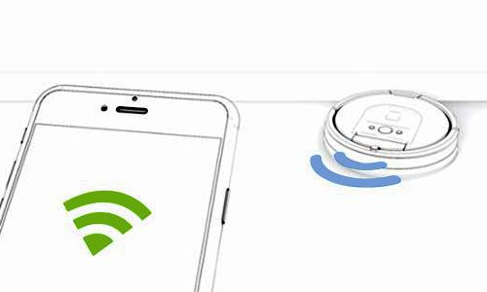

**Figure 2: IVector connected to the Smart Phone (neato)**

**Steps to connect IVector to the Wi-Fi:**

1. **Network Confirmation**: The application on the phone will display the name of the Wi-Fi network that the mobile is currently connected with.
2. **Enter the Password**: Please enter the password for the Wi-Fi network that is being used.
3. **Activating the IVector**: Here the IVector will generate its own Wi-Fi network. For the activation of the i-Vector, we have to press and hold the DOCK and SPOT button simultaneously for 5 seconds. After the process, IVector will release a sound and a green light Wi-Fi signal will be displayed.
4. **Connect the mobile to IVector**.
5. Setup the Network: The password for the network and other various information will be sent to the IVector. IVector will successfully join our home’s network.

**[FN-02] -> Machine Learning and Computer Vision:**

The product IVector is built with strong machine learning integration. The obstacle detection sensors in our product provides continues inputs to the securely built machine learning algorithms making the system more cautious about the surroundings. This makes our product learn about the environment and makes it smart. Using the computer vision technology, application designs the outlook of the machine work environment. IVector scans the surroundings like living room and beams the inputs to the customer’s mobile application. The mobile application prepares the bitmap of the environment and uploads the new synthesized smart map to the device.

Following are the advantages of applying Machine Learning in our project:

* Machine learning algorithms helps to identify the pets from other objects in the room. This helps the machine to rectify the bitmap in case of any pets being classified as the objects/obstacles in the room.
* Advanced data collection with machine learning helps to optimally plan the cleaning path to cover the whole house with minimum number of movements.
* With the help of machine learning “Quiet Hour” feature is developed. This helps to plan the cleaning activity when there is minimal movement in the house. System observes the environment to plan the Quiet Hours. (As a part of privacy concern the user is prompted for the authorizations).
* IVector also collects the data on amount of dust collected in every run. This aggregated data is used with specialized machine algorithms to calculate which all day’s maximum maintenance is needed. This helps to reduce the everyday cleaning
* IVector actively plans which all areas in house needs more frequent cleaning. This is decided on the dust collection data.
* IVector’s maintenance schedule is also planned by the algorithms.

Overall Machine Learning helps to reduce the cost of operation and increases the over-all efficiency of the IVector. Advancement of machine learning is a game changer in the smart vacuum industry.

**[FN-03] -> SEVERAL MODES OF OPERATION:**

The product has several modes of operation (listed below). Each mode focusses on developing a unique functionality and capability. The modes are:

1. **Smart cleaning mode**
2. **Outdoor mode**
3. **Deep cleaning mode**

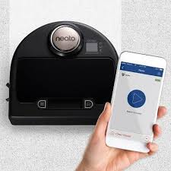

These modes can be selected and changed by following the simple steps:

1) **Go to the IVector app**

**2) Open settings**

**3) Select “Mode”**

**4) Select the desired mode out of the listed modes.**

**Figure 3: Robot vacuum (Neato)**

All the three modes differ in their functionalities and the way they perform the operations. The modes are separately defined in order to have a product which related to different normal life conditions and therefore works in a way which makes human life more comfortable and convenient. Thereby, solving the purpose of being a smart device. Classification of the given three modes is listed below, which makes easier to understand that when a particular mode can be used.

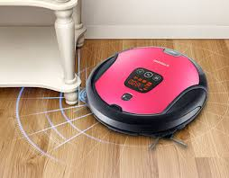

**Figure 4: Robot vacuum (Neato)**

* **Smart Cleaning Mode-** This mode emphasizes on smartly cleaning the visible dirt.
  + Dirt detection
  + Dust vacuuming
  + Smart sensing technology

This mode is best suited for dusting around the house. This built in mode tells the device to look up for certain types of dirt which do not require deep cleaning.

* **Outdoor Mode:** where the device works upon cleaning the outdoor dirt. The functionalities include:
  + Lawn cleaning
  + Dirt sensing and removal
  + Dust removal
  + Smart vacuuming
* **Deep cleaning Mode:** where the device is oriented to work indoors. The indoor functionality includes:
  + Spot detection
  + Spot removal
  + Cleaning under the furniture
  + Sensing the corners
  + Automatic periodic assessing

**[FN-04] -> VOICE RECOGNITION:**

IVector supports voice recognition feature through Alexa and Google home. In current days, Alexa and google home are most widely used for voice recognition feature as they have been upgraded to grasp complex commands. IVector is basically connected to Alexa or google home via an application on your smartphones. This feature makes the use of IVector easier and more convenient. IVector identifies the voice commands provided and performs the operations as specified by a human. Using the voice recognition feature we can schedule the IVector to work during a specified time. This voice recognition feature can basically be used:

• To start and stop the operation of IVector.

• To schedule the working of IVector.

• To clean the dirt immediately, IVector can be set up using this feature.

• To remove dirt from surfaces like blankets and carpets, IVector works very effectively.

The voice recognition feature for IVector has a lot of advantages. One is it can be operated anytime and from anywhere. It can also perform all operations through the commands received. These commands are stored and used as and when necessary which makes it efficient in terms of time perspective**.**

**[FN-04] -> SENSORS:**

To properly clean a floor, IVector needs some space to move freely. For this purpose, IVector needs to use various sensors to detect any object, wall or furniture that can come on its way. Along with detection, these sensors can also measure how far an object or hazard is from it and can find out a new area to clean. These sensors generate automatic actions that determine how the IVector responds. Just which sensors IVector uses and how they work can vary by manufacturer and model, but these are common to all:

* **Obstacle/Object Sensors**: In our home, we know chairs, tables, sofas will all come under obstacles. Sensors of the IVector will let it know about obstacles presence and will show or indicate the area that is free from obstacles without wasting it’s time to slow time or just bump into an obstacle. When IVector sensor will get triggered and give a signal to the IVector be away from it, then it will move in the opposite direction and will find another place near it to clean. For example, if it will get to know that there is any obstacle in its right then it will generally turn left because it has discovered the obstacle to be to its right.
* **Wall Sensors**: Using infrared light, wall sensors will help IVector to detect walls so that they can follow along them and it will allow the IVector to clean along with boundaries where a wall meets the floor. In models with plotting capabilities, wall sensors can also help the IVector follow around open entranceways and determine new areas to clean.
* **Cliff sensors:**Stairs are the biggest threat for IVector; a collapse could damage the IVector and anyone in its path. Because of this, cliff sensors will be a safety requirement on all robot vacuums. The distance to the floor will be measured continuously by forwarding infrared signals to its surface. If the signals don’t instantly bounce back, the robot assumes it has reached a stair or any cliff and will change its direction.
* **Wheel sensors:**A sensor that will measure wheel rotation or the wheel circumference, so that it can get to know how far it has traveled.

**[FN-06] -> IVector IOS AND ANDROID APPLICATION:**

Our team has come up with the sophisticated mobile application for IVector which is available in both IOS and Android platforms. A strong visual harmonization has been maintained between these two platforms to facilitate the users with same smooth experience.

With the help of IVector mobile application users of IVector get superior control on device working. In this section we will see all the functionalities available in Mobile application.

* **Mode of Operation**: Users can enable the autonomous working of the product by enabling the button.
* **Scheduler**: Scheduler is one of the most requested features for automatic vacuum cleaner. Customers can schedule which time in the day/week IVector should do the job.
* **House Map**: Map of the house prepared by the IVector can also be viewed by the user. Users can prohibit the entry of IVector to certain rooms by selecting the intuitive Map UI and selecting the prohibit icon.
* **Analytics**: In this section users will be able to see the data collected by the IVector regarding the amount of dust collected and the toxicity amount in the dust. Users will be provided with the pleasing charts to depict the data.
* **Voice Recognition and Training**: IVector can do the work based on the voice commands. User needs to train their voice with the application first to use this feature. Once the voice is setup the i-Vector device can recognize the voice without the help of mobile application.
* **Logs:** Logs section provides the users with the last 20 activities of the IVector. It also provides how long the device was working and which all areas the device has visited in the house (MAP). This feature comes in handy when the user had selected autonomous mode for the working of I-Vector.
* **Crash Logs:** Whenever the IVector device encounters any error, the error is recorded and beamed to the mobile application. All the error logs were written in details with possible fix with pictorial depictions. Users can send these logs to IVector team in case they fail to understand it.
* **Privacy:** All the data collected by IVector’s sensors and machine learning algorithms are saved in this section. Incase users feel that the data is voiding their privacy limitation they can completely delete that data and also disable the IVector from collecting the similar data.
* **Updates:** Any system firmware updates for the IVector device will be shown in the updates section of the application. Once the user grants the permission the firmware update will start in the device.
* **Feedbacks/ Request for a new Feature**: Users can request for any new features using the Feedback/Request feature section. Once the user requests the feature our team will access the possibility of the feature and communicate with the user.
* **Disconnect from IVector**: Users can disconnect from their IVector application by using the disconnect option. This option comes in handy when users change their phones or sell old i-Vector.
* **Factory Reset**: Incase if the users want to completely reset the IVector they can use the Reset option
* **Connect to new IVector**: Users can connect to multiple IVector devices using the same application without needing to disconnect from the old IVector.

**How to connect to IVector?**

User selects the connect to IVector from their mobile application.

System prompts to make sure that IVector device is switched on.

Once system detects the IVector’s signals it asks user to press auto button 3 times in the IVector device to authenticate the pairing

On successful pairing user gets a beep in the device and successful message in the application.

**[FN-07] -> Auto Failure Detection:**

IVector application provides the auto failure detection feature. The main purpose of this feature is to give instructions to the user how to use the product if it is not working. The application detects the error where the user as done the mistake and describes the instructions on how to refit the part properly. If any parts are not working, it will inform the user to replace it with new one or call/mail the customer care with error code generated by the application. Using the error code, the customer care informs the dealer in advance to take parts which are needed for the product to repair.

**Regular Updates for Application**

IVector application will have regular updates every month. Updates will mainly contain the improved user experience, minor bugs and new features which are implemented after several tests. The user can report on the application if he/she is facing any problems with applications. The company is also open to the feedback provided by the customers. The developers will focus on the issues reported by the users and fix them in the next update.

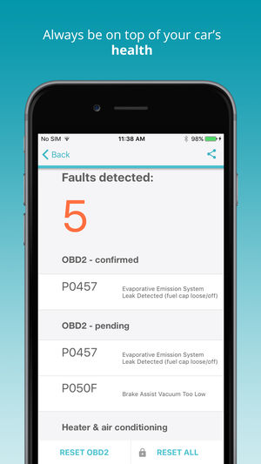

**Figure 5: Fault Detection (Carista OBD2 Application)**

**[FN-08] -> SECURITY FOR IVECTOR:**

The product is an essential feature of smart homes and therefore may face the problems associated with Internet of things. The designers at Innvotec take complete care of the security aspects of the product. The essential security measures included in the product are:

* **Double- authentication for login.**
  + Double authentication provides several modes of authentication, which can be managed by the user of the product through the mobile application. This can be simply achieved by following the mentioned steps:

**1) Open the I-vector app - -> 2) On the left panel select “authentication” - -> 3) Select the mode of authentication from the visible list - - > 4) Set-up the selected mode.**

The brief description of the available modes is given below: 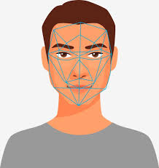

**i) Facial Recognition-** facial recognition is a way of recognizing facial features from photograph or video to map the features using biometrics. The obtained information each time is compared with the existing database for the purpose of identification and therefore, authentication.

**Figure 6: Facial recognition (Airfreshner.club)**

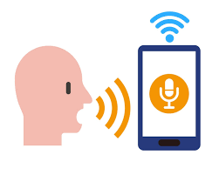

**ii) Voice recognition-** the analog waves of the user’s voice are translated into digital data by sampling the sound. This takes place in a number of steps which show up once entering the set-up domain.

**Figure 7: Voice recognition (Thinkstock.com)**

**Figure 8: Thumb print image (Iconscout.com)**

**iii)Thumb print recognition-** the system uses a build in scanner using light-sensitive microchip to produce a digital image. The system analyzes the image automatically, uses pattern matching software’s to establish authentication and thereby ensuring security.

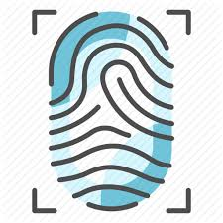

**Figure 9: Unlock image (Cryptoworld.com)** 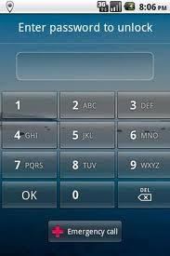

**iv) Pattern input-** the user may set-up a number or pattern of alpha-numeric characters in order to establish identity, for it to be sued as a method of authentication.

* Automated notification system for unrecognized connection/activity.
* Self-turn-off mode when not in use.
* Recommends usage of strong and unique password.
* Universal plug and play mode is turned off.

These features are implemented in order to ensure the secure usage of product and thereby avoid any type of security breach through the product.

* Any changes made to the security settings may lead to vulnerability in the system. It is recommended not to change the essential settings without the manufacturer’s advice.

** Any damage caused through such actions will not be covered by the manufacturer.

**6.** **IMPLEMENTATION**

**Physical implementation of the product:**

Automatic floor cleaner is a compact autonomy framework which gives floor cleaning facilities in room and huge workplaces diminishing human work. Fundamentally as a robot it disposes of human errors and furnishes cleaning movement with substantially more effectiveness. Additionally, because of difficult work included this is tedious and aggravating to clean the floor. In huge workplaces floor region is exceptionally tremendous and the general faculty required there for cleaning may not do it efficiently. This is the place where robotic technology comes as favorable part. Likewise, the robot is small and minimized in size. So, we can carry it and spot it wherever we can inside the house or offices.

Various robotic parts are

* **Pneumatic devices**
* **Actuators**
* **Sensors**
* **Mechanical Control Devices 🡪 valve**
* **Microcontroller 🡪 Controlling Unit**

There are number of subtasks involved to control the automation of the smart robots:

* **Understanding the mechanism**
* **Path Planning**
* **Integrating the sensors**
* **Coping with uncertainties**
* **Creating flexible control policies to deal with unplanned situations**

**Sensors**

Device that detects (senses) changes in the ambient conditions or in the state of another device or a system and conveys or records this information in a certain manner. They play a very important role in every type of bots. It’s a transducer whose intention is to sense obstacles which is normal for its environ. The yield of the sensors is measured when the amount of data measured changes i.e called sensors affectability. The transducer present in sensors converts the physical signal to electrical. The electrical signal sensed is of small range; hence we use an amplifier to amplify the signals to high gain of volt range. Different type of sensors are ultrasonic distance measurement, sound sensors, pressure sensors, touch sensors, temperature sensors etc.

**IR SENSORS:**

It has two main components, one to send the infrared light signals and the other component get the reflection of the signals and gauges the distance of the object and sends it to the main microcontroller for further processing. They also have the capacity of measuring the heat being emitted from the distant or nearing object, also whether the object is in motion or not. This sensor will readily be useful for implementing in smart robot devices like vacuum cleaners. IR sensors are of sharp types which belong to a family of GP2Y0A21YK0F and can measure a distance of 10-80cm. These are also known for sensing any rapid steep inclination or any stairs. The IR sensors detect the sudden change in the height from where it was placed.

**LDR SENSORS:**

The light dependent resistor, as the name indicates it works on the light intensity. The resistance of the sensor decreases with the increase in light intensity. The “Photo resistor” or the “Photo conductor” the other names of the LDR sensors uses a high resistance semiconductor material which helps the electron in valance band of the material to gain some energy and jump to the conduction band emitting energy. So the thermal energy gained helps the electron to jump to conduction band with the incident photons. The electron hole pair gets generated which increases the conductivity and reduces the resistivity.

**ULTRASONIC SENSORS:**

This sensor is apt for any robotic applications because all the robotic application requires accurate ranging. These are high performance sensors in finding the range anywhere between 2cm – 4m. These are advantageous because they can be connected directly to input – output pins of the main microcontroller. Obstacle avoidance is one of the primary requirements for any autonomous mobile robots. The robot collects the data from the surrounding elements using sensors mounted on them. Usually these are mounted one opposite to the other to monitor the dirt entrance and calculate the amount by voltmeter circuit.

**MAPPING SENSORS:**

The Radio frequency transmitter and receiver in addition with the light help the vacuum cleaner to know when it runs low of battery. The receiver decodes the encoded digital wave to analog wave.

**BLUETOOTH:**

To monitor the Ivector when the human interaction is unavailable there can be a mobile app installed and the device can be handled in the absence of humans around. This can be done using a Bluetooth technology. The Bluetooth device HC-06 is attached to the robot which receives and transmits the data signals from the mobile phones. There are two modes served – the master and the slave. The client-server architecture helps in forming the personal area network and runs at a speed of 2.4GHz with a wireless communication protocol.

**SMART BATTERY:**

The Ivector will be installed with the charging plugs and batteries as one of the basic components. Usually these are made automatic to complete the assigned task without the intervention of human beings. Hence when there is no one to help charge the power bots, the smart vacuum cleaner will be trained to return to the docking station to be charged in auto clean mode. So once the battery is charged to the two third of the level it recommences to complete the cleaning work of the remaining area. There will be an emergency switch provided at the bottom of the device which can be turned on when no one will be there to home. Also, if the smart vacuum cleaner cannot reach the charging socket or docking station automatically power saving mode will be enabled and the display screen will be turned off.

**How IVector will Work:**

IVector will run on rechargeable [battery](https://electronics.howstuffworks.com/gadgets/home/battery.htm)**.** I will take 3 hours to fully charge. A full charge will be equal to approximately two hours of cleaning time, which means for IVector to vacuum three medium-size rooms. The mobility system contains two motor-driven, tracked wheels. IVector steers by alternating the power provided to each wheel.

**Total of five Motors will be required by IVector:**

1. One driving each wheel (2 total)
2. One driving the vacuum
3. One driving the spinning side brush
4. One driving the agitator assembly

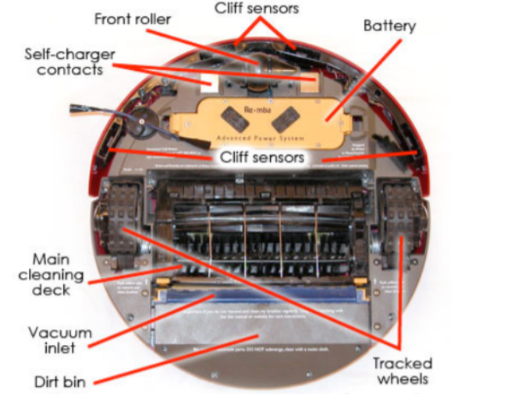

**Figure 10. Internal Parts of IVector (How Robotic Vacuums Work - howstuffworks.com)**

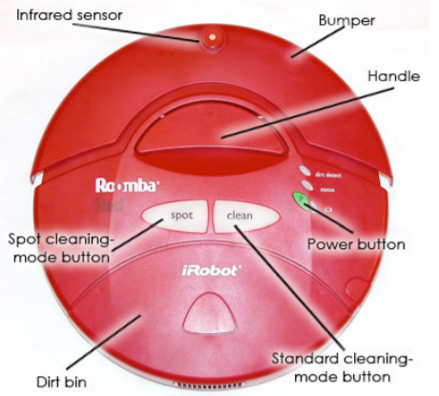

**Figure 11. External Parts of IVector (How Robotic Vacuums Work - howstuffworks.com)**

**Self-Navigation System:**

IVector will make use of iRobot's AWARE Robotic Intelligence System for making many decisions for itself, so human input will be less required. The AWARE system is consisting of multiple sensors that will detect anything in its surrounding.

**How IVector will move in its environment:**

First when we will press the clean button, then it will calculate the size of the room and will get to know how long it will take him to clean it. Then it will make use of an infrared receiver or sensor that will help it to receive infrared signals from its surroundings.

While Cleaning, IVector prevents its movements using four infrared sensors, those will be on the front underneath of it.

**Cliff sensors** constantly send out infrared signals, and IVector assumes them to instantly rebound back. If it is going near a cliff, suddenly the signals will get lost. This is how IVector will get to know that it has to head another way.

**Object Sensors** will get activated when IVector bumps into an object and its bumper pulls back. This will let IVector know that it has run into an obstacle and then it will pull itself back, rotates and starts moving forward till it finds a clear path.

**Wall Sensors** will be located on the right side of the bumper and it will let IVector know to clean very carefully along walls and around objects without touching them. This means it can clean nearby any obstacle without bumping into it.

**Wheel Sensors** will measure wheel rotation or the wheel circumference so that it can get to know how far it has traveled.

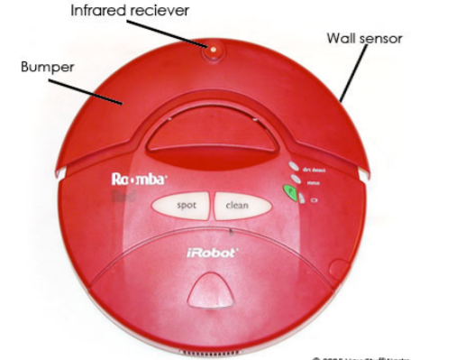

**Figure 12. IVector with Wall Sensor (How Robotic Vacuums Work - howstuffworks.com)**

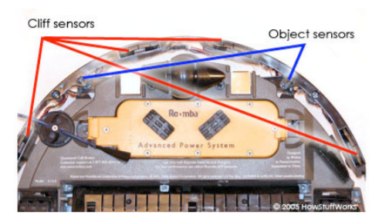

**Figure 13. Cliff and Object Sensors of IVector (How Robotic Vacuums Work - howstuffworks.com)**

**Self-Charger**:

Ivector will arrive and attach to the charger all by itself when its battery power will be low

**IVector’s Cleaning System Parts:**

**Vacuum**- The vacuum that it contains will suck up dust and dirt when IVector moves upon the floor.

**Agitator**-Agitator will consist of two counter-rotating brushes, out of which, one grasp dirt and other one deposit it in the dirt bin.

**Spinning Side Brush**- It will help IVector to clean spots, those are difficult to reach, under any furniture.

IVector will have two dirt sensors located directly on the top of the agitator brush, those will help it to figure out which part needs extra cleaning. When dirt will hit metal plates of sensors, it will vibrate more. So, in this way, the sensor detects that dirt is more over there and will tell IVector to go over that area again. To make the transition between floor types, IVector’s cleaning deck automatically adjusts its height when it senses a half-inch rise in the floor surface.

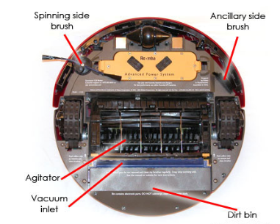

**Figure 14. IVector’s Cleaning System Parts (How Robotic Vacuums Work - howstuffworks.com)**

**So, Overall IVector Consists of following parts:**

1. Motors
2. Sensors
3. Power Button
4. Spot Cleaning Mode Button
5. Standard Cleaning Mode Button
6. Self-Charger Point
7. Battery
8. Tracked Wheels
9. Dirt Bin
10. Vacuum Inlet
11. Main Cleaning Deck
12. Front Roller
13. Agitator
14. Spinning Side Brush
15. Ancillary Side Brush
16. Bumper
17. Handle

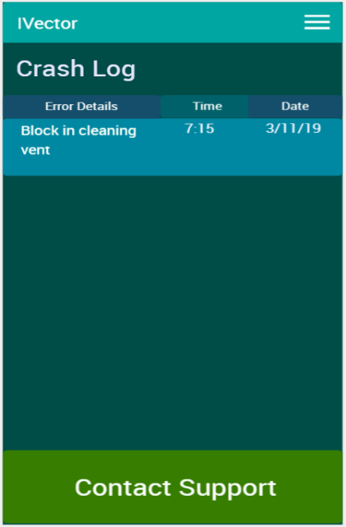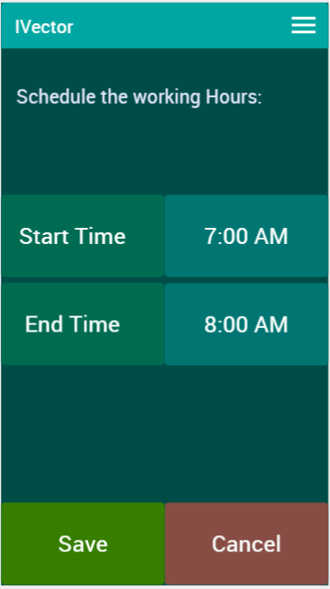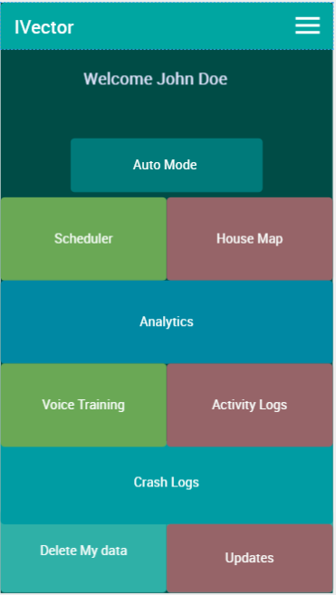**Wireframe Mock-ups**

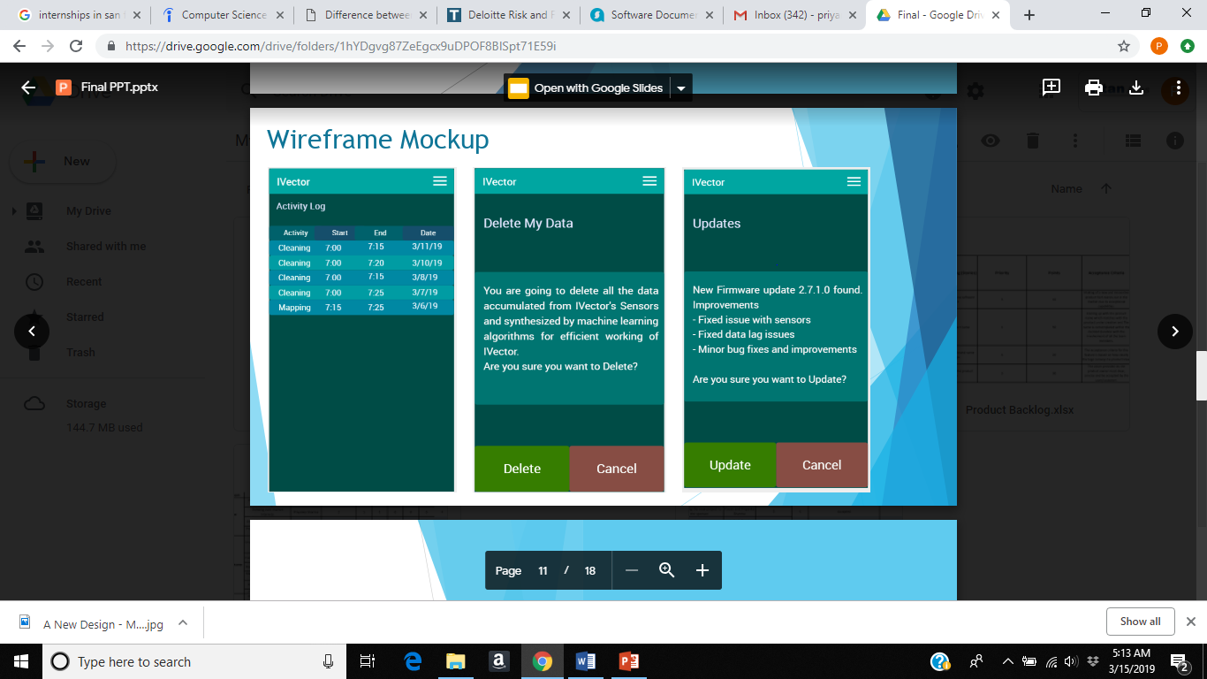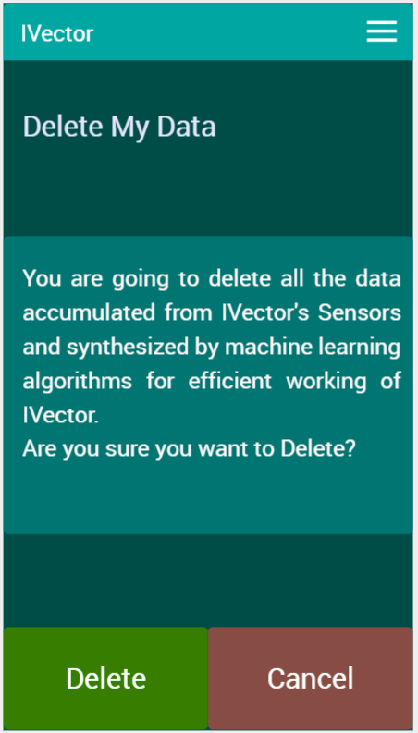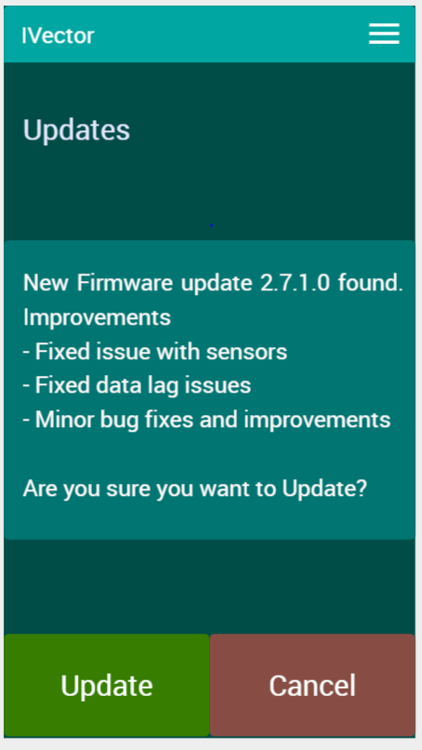

**7.** **LOGISTICS**

**Warranty Policy:** Warranty is limited for only 6 months which comes default when you purchase the product. There is add on warranty policy for extra amount which is valid for two years. Below table shows the pricing and the what all covers under the warranty policies.

|  |  |  |
| --- | --- | --- |
|  | Innvotec Silver  (Default warranty) | Innvotec Gold  (1 Year) * |
| Pricing | **$0** | **$50** |
| Hardware Fault | **🗸** | **🗸** |
| Parts* | **-** | **🗸** |
| Free service | **🗸** | **🗸 (1 year)** |
| Battery | **-** | **1 Year** |

What all is not covered?

* Rough and tough usage may cause defects will be not covered under any warranty.
* Parts such as filters and brushes is not considered.
* Use of uncertified spare parts will terminate the whole warranty agreement.
* Any unauthorized dealer repairing the product.
* Damaging the product intentionally.
* Purchasing from the unauthorized dealers.
* Due to weak wireless signals.
* Batteries are not covered when there is used for different purpose.

**Pricing:**

Ivector product comes with two variants which are ivector basic and pro. Ivector basic comes 3-speed suction which costs around $299. It doesn’t include the fitting parts which can be purchased separately. Ivector pro comes with 5-speed suction which costs around $599. It comes with fitting parts and as special features specifically limited to this model.

**8. FUTURE**

UPCOMING UPDATES IN IVECTOR

The vacuum cleaner can be controlled by using an app or a button on the top or an automatic cleaning schedule that is set up already or by combining the above methods. There are many updates that can be applied to the vacuum cleaner.

**Solar energy**

Solar energy is the most abundant energy which is cheaper and does not contribute to greenhouse gas emissions. Some solar panels come with the built-in charge controllers and inverters, but they are not strong enough for running a vacuum cleaner. The amount of power generated by a single solar panel must be calculated and then check for the number of panels to be connected to generate the required power. This collected energy is converted to electrical energy and fed to the batteries. These help in charging and discharging the batteries.

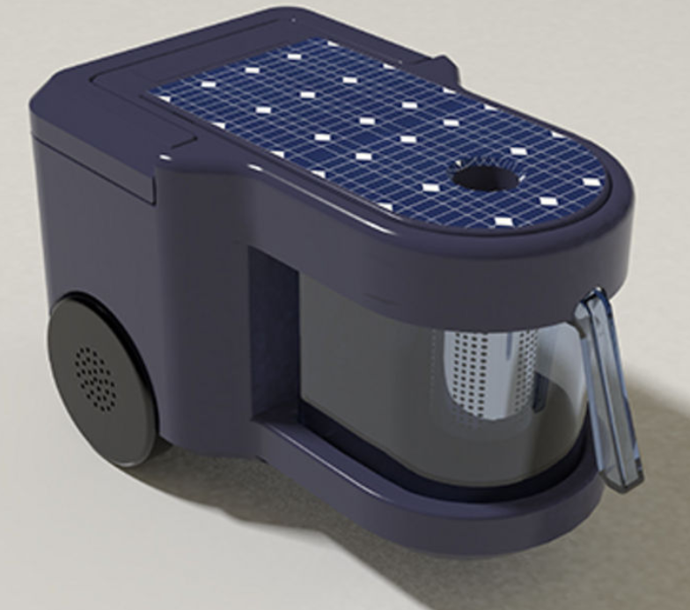

**Figure 15: Solar energy (Buzzfeeds.win)**

The above figure shows the image of a cordless vacuum cleaner using the solar power with a portable battery. The battery can be removed from the vacuum cleaner and placed under the sunlight for recharging. This also has a charging controller placed between the solar plate and the battery. When the battery is fully charged, it disconnects the battery from the solar. This detachable battery can be used by other home appliances also by plugging to it.

**Cleaning modes**

* Manual cleaning mode: The robot moves front and back and side-ways. It can be used to clean the desired spot by just starting it. It can sometimes run into obstacles if it is set to clean an area full of obstacles.
* Spot cleaning mode: The robot is placed in the area to be cleaned again and again. The area which is dirty or filled with some food s like bread or cookies need to be cleaned again and again. When the spot cleaning is initialized the robot cleans the given area only again and again repeatedly.
* Turbo mode: This mode can be selected for more intense and powerful cleaning. This reduces battery duration. This mode gets activated automatically on carpets. It cleans the area in zigzag pattern.
* Repeat mode: This mode can be selected for the robot to continue cleaning the area again and again till the battery runs out. It will keep cleaning the whole house continuously.
* Learning mode: In this mode the robot learns to memorize the cleaning environment. It learns about all the obstacles to avoid them. It learns about every minute thing it comes across right from the starting point to the ending point. If any changes are made in the house the cleaning robot has to be set to learning mode before starting to clean. Once the learning is complete it will give an alert that the task is completed.

**Scanning the space**

The robot can now scan the room space available for it to clean. It can create its own virtual floor plan and find a cleaning route from where it has to start and where it has to end. The user can break the floor plan into smaller zones for better cleaning. So, the robot will know which zone it has to clean more and which zone more dust will be accumulated. The user has to setup the zone parameters in the app and setup overlapping zones for more efficient cleaning. It can clean the floor in zigzag or by choosing cell by cell. When they select cell by cell cleaning, the robot divides the area into rectangular spaces and first cleans the borders of the area. Then it cleans the inner area in zigzag pattern. The user can also setup an No-Go-Zone where you don’t want the robot to do the cleaning.

**CONTACT INFORMATION**

Talking to us is easy

[Call us1-866-693-9766](tel:1-866-693-9766)

US based Helpline open:

8:00am - 8:00pm CST Monday to Friday  
9:00am - 6:00pm CST Saturday

Help n Support Online:

[Troubleshooting](https://www.dyson.com/support/journey/troubleshooting.html)  
[Parts, tools and accessories](https://www.dyson.com/support/journey/replacement-parts.html)  
[Guides, tips and manuals](https://www.dyson.com/support/journey/guides.html)

Contact us : 1-657-448-9482

Register your i-Vector

[Register your warranty](https://www.dyson.com/register.html)  
[Registration for business users](https://www.dyson.com/b2b-machine-registration.html)

Contact us: 1-714-726-8426

Help from i-Vector experts

[Repairs and servicing](https://www.dyson.com/support/journey/repairs-and-servicing-information.html)  
[Find a Dyson Demo Store](https://www.dyson.com/support/journey/dyson-demo-stores.html)  
[Contact us](https://www.dyson.com/support/journey/contact-us.html) : [1-866-693-9766](tel:1-866-693-9766)

Email us :

support@i-Vector.com

**REFERENCES**

* Fingerprint icon, Iconscout.com

<https://iconscout.com/search?asset=icon&color=%23000333&price=premium&product_type=item&query=Fingerprint&sort=relevant>

* Facial recognition, airfreshner.com

<https://airfreshener.club/quotes/authorized-software-use.html>

* How Robotic vacuums Work, howstuffworks.com <https://electronics.howstuffworks.com/gadgets/home/robotic-vacuum.html>
* IOS carista OBD2 application

<https://itunes.apple.com/us/app/carista-obd2/id954363569?mt=8>

* Phone unlocking, cryptoworld.com
* Robot details, neato

<https://www.neatorobotics.com/robot-vacuums/products/>

* Solar cleaner, Buzzfeeds.win

<http://buzzfeeds.win/blog/remodeling-your-kitchen-should-you-hire-a-decorator/>

* Voice recognition, Thinkstockphotos.com

<http://www.thinkstockphotos.com/image/stock-illustration-voice-assistance-system-concept/844394120>